**DAILY ONLINE ACTIVITIES SUMMARY**

|  |  |  |  |  |  |  |  |  |
| --- | --- | --- | --- | --- | --- | --- | --- | --- |
| **Date:** | **05/07/2020** | | | | | **Name:** | **NIKHIL KUMAR** | |
| **Sem & Sec** | **4thSEM. & ‘B’ SEC.** | | | | | **USN:** | **4AL19CS400** | |
| **Online Test Summary** | | | | | | | | |
| **Subject** | | **NULL** | | | | | | |
| **Max. Marks** | | **30** | | **Score** | | |  | |
| **Certification Course Summary** | | | | | | | | |
| **Course** | **Built your own chatbot** | | | | | | | |
| **Certificate Provider** | | | **Cognitiveclass** | | **Duration** | | | **1 week** |
| **Coding Challenges** | | | | | | | | |
| **Problem Statement1:---** | | | | | | | | |
| **Status: ---** | | | | | | | | |
| **Uploaded the report in Github** | | | | | **Yes** | | | |
| **If yes Repository name** | | | | |  | | | |
| **Uploaded the report in slack** | | | | | **Yes** | | | |

**Online Test Summary : Not conducted**

**Certification Course Summary: Today I went through the module5 : Deploying your chat-bot which includes ”Deploying to a word press site, lab8, lab9 with quiz”.**

**Snapshot is given below 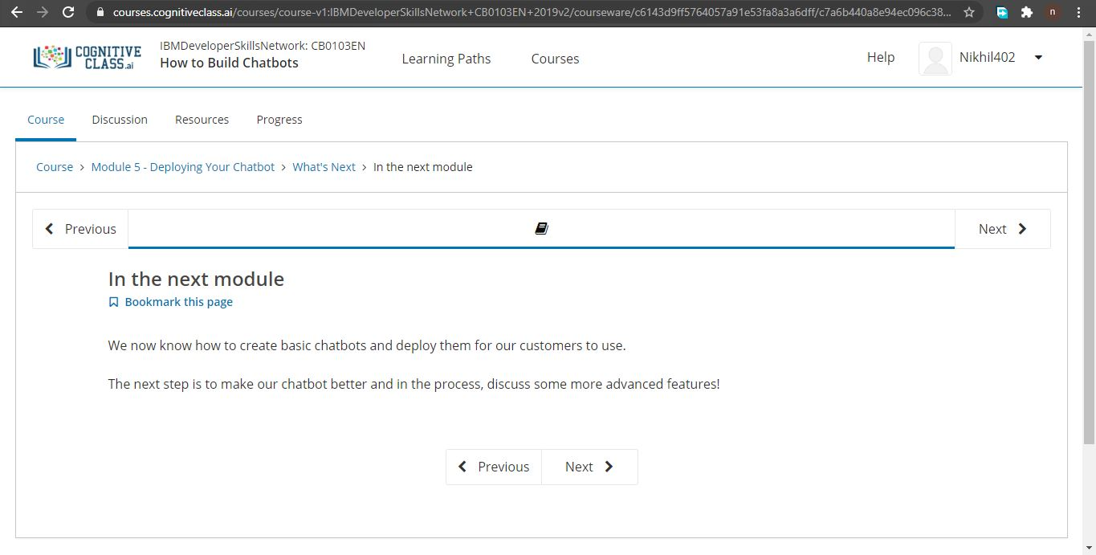Online Training : NOT CONDUCTED**

**Online coding summary:** ----

**Thank you.**